**Topic 7: Structured Products and New Products**

Credit Derivatives (CDS)

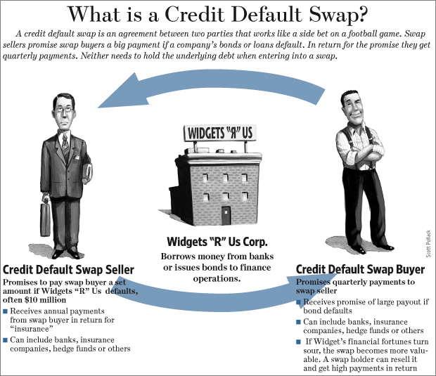

* Asset-backed securities
* Basis
* Basket CDS
* CDS spread
* CDX
* Cheapest-to-deliver
* Counterparty risk
* Credit curve
* Credit default swaps
* Credit derivatives
* Credit events
* Deal spread
* Deliverable obligation
* Hard events
* iTraxx
* Mark-to-market
* Notional amount
* Novation
* Protection buyer
* Protection seller
* Recovery rate
* Reduced form
* Reference entity
* Reference portfolio
* Risk-neutral pricing
* Risky PV01
* Single-tranche collateralized debt obligation (STCDO)
* Soft event
* Structural approach
* Subordination
* Tranche width
* Unfunded

1. **Describe and calculate expected credit loss.**

* Expected Credit Loss = (PD )x (ED) x (1-recovery rate)
* = Probability of Default x Exposure at Default x (1- recovery rate)
* The concept of expected credit losses (ECLs) means that companies are required to look at how current and future economic conditions impact the amount of loss.
* Credit losses are not just an issue for banks. ECLs on trade receivables are measured by applying either the general model or the simplified model.

**2. Explain the concept of arbitrage-free risk models.**

* An ideal credit risk model should be arbitrage free. An arbitrage free model is one that either uses market prices as inputs or that can be used to price the most liquid segment of the market.
* An arbitrage free term structure model is one that can generate prices that are consistent with current observed prices of most liquid segments of the market. This means that an ideal model should be flexible enough so that it can price various instruments.

**3. Argue why traditional pricing models (e.g., CAPM) cannot be used to price credit risk.**

* Default is a relatively rare event, and therefore, typically, little or no observations are available to estimate various statistics
* Default is generally a binary event that may occur for various reasons – from changes in macroeconomic conditions to mismanagement at the firm or country levels
* Many financial institutions that invest in credit products are not able to hold diversified portfolios of credit spreads to eliminate the idiosyncratic risks of these securities
* In some case credit risk may arise not just because of the inability of the counterparty to pay, but also because of its unwillingness to do so.

**4. Describe the relationship between the price of risky debt and the price of equity of the same firm in the context of the structural approach to pricing credit risk.**

* The structural approach (BS) was developed by Merton (1974). It is based on the option pricing model of Black and Scholes. The underlying assumption of the model is a process for market value of a firm’s assets.
* The underlying assumption of the model is a process for market value of a firm’s assets. Default will take place if the value of the firm’s assets drops below a given threshold.
* Therefore the credit risk of the risky bond is captured in the PUT option price via the structural model.

**5. Calculate the price of risky DEBT using the binominal approach. Pg 278. Integrated Topics and Applications**

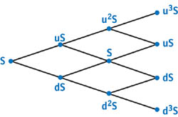

* Value(0) = [Prob. x Vup + (1-Prob.) x Vdown] / (1 + r) 🡨 don’t forget discounting
* PUT = [Prob. x 0 + (1-Prob.) x Vdown] / (1 + r)
* BOND = K / (1+r) - PUT K=Face Value

**6. Identify the major advantages and disadvantages of Merton’s approach to the pricing of risky debt.**

Advantages:

* Uses Fundamentals of debt issuer (Balance Sheet, marked value of assets)
* Fixed income can be used to price equity
* Model is flexible enough to price related fixed-income securities
* Modeling default correlation is straightforward

Disadvantages:

* Equity distortions will misprice Fixed-Income (Bubbles)
* Computed credit spreads are not good for short term
* Assumes that tradable assets can be hedged
* Data on firm liabilities may be limited
* Economic behavior may change as the firm approaches default
* Financial institutions are regulated so asset value may be < liabilities
* Complexity of sovereign issuers may not be added

Note: “Robert Merton and Meriwether”

The Merton model, developed by Robert C. Merton in 1974, is a widely used credit risk model. Analysts and investors utilize the Merton model to understand how capable a company is at meeting financial obligations, servicing its debt, and weighing the general possibility that it will go into credit default.

Under this model, the value of stock equity is modeled as a call option on the value of the whole company – i.e. including the liabilities – struck at the nominal value of the liabilities; and the equity market value thus depends on the volatility of the market value of the company assets.

The idea applied is that, in general, equity may be viewed as a call option on the firm: since the principle of limited liability protects equity investors, shareholders would choose not to repay the firm's debt where the value of the firm is less than the value of the outstanding debt; where firm value is greater than debt value, the shareholders would choose to repay – i.e. exercise their option – and not to liquidate.

Also:

Merton extended Black Scholes:

Several assumptions of the original model have been removed in subsequent extensions of the model. Modern versions account for dynamic interest rates (Merton, 1976), transaction costs and taxes,and dividend payout.

**7. Describe the reduced form model and calculate the price of risky debt using the reduced form model.**

* They do not explicitly attempt to model default probabilities.
* Rather, reduced form models take the market prices of liquid securities and infer the market’s expectation of default

**8. Understand the relationship between credit spread and probability of default using the reduced form model.**

* The risk neutral probability of default is = credit spread / expected loss given default (1-R).

**9. Identify the major advantages and disadvantages of the REDUCED form approach to the pricing of risky debt.**

Advantages:

* Model incorporates fixed-income assessment of default
* Simple and user friendly and can price derivatives easily
* Model can adjust for credit rating changes
* Model can be used when balance sheets are NOT available

Disadvantages:

* Reveal limited information about the fixed income securities used in their calibration
* Sensitive to assumptions
* Do not have default probability rates

**10. Compare the following:**

a. Single-name vs. Multi-name credit instruments.

Single

* CDS is the most widely used single name credit derivative.

Multi-Name

* CDX and ITRAXX are example of multi name credit instruments.

b. Funded vs. Unfunded credit instruments

* CDS is Unfunded
* Unfunded instruments expose one party to increased counterparty risk.
* Funded involves the transfer of NOTIONAL

c. Sovereign vs. Non-sovereign linked credit instruments

* Modeling credit risk associated with sovereign risk involves political and macroeconomic risk that is normally not resent in modeling corporate credit risk.

**11. Explain how major participants in credit derivatives markets use these instruments**

* Bank trading activities

Market makers in the credit markets were constrained in their ability to prove liquidity

* Bank Loan portfolios

Banks developed the CDS market in order to reduce their risk exposure to companies to whom they lent money

* Hedge funds

Many funds now use CDS as the most efficient method to buy and sell credit risk.

* Other asset managers
* Asset managers use CDS because they do not provide the same opportunities in the bond market

Insurance companies

1. Life insurance
2. Monolines and reinsurers

Corporations

Use credit derivatives to manage credit exposure to third parties

**12. Describe credit default swaps (CDS).**

ISDA reports that the CDS market has grown from 632 billion in notional value in 2001 to over 45 trillion in 2007.

**13. Describe the six factors that have contributed to the growth of the CDS market.**

1. Isolates pure credit risk
2. Cheap and effective
3. Synthetically creates credit exposure
4. Provides liquidity
5. OTC

**14. Identify the issues addressed by the International Swaps and Derivatives Association (ISDA). Like a contract.**

* Reference entity triggers
* Deliverable obligations
* Notional Principal
* Settlement Procedure

**15. Identify various hard and soft credit events defined by ISDA.**

Hard Events

* Bankruptcy
* Failure to Pay
* Obligation Acceleration
* Repudiation/Moratorium

Soft Events

* Restructuring

**16. Describe the risks associated with CDS and contrast the risks faced by protection buyers with the risks faced by protection sellers. CounterParty**

BUYER

* The reference entity defaults and the protection seller is unable to pay the motional amount to the projection buyer on delivery of the appropriate obligation
* The reference entity does not default but the protection seller files for bankruptcy, thus making its projection worthless

SELLER

* Less obvious counterparty risk if Buyer doesn’t pay
* Mark to Market risk

**17. Explain the concept of marking-to-market of CDS and identify the factors that affect the marking-to-market valuation of a CDS.**

1. Financial Statement Reporting
2. Economic Gain Realization
3. Collateral Management

**18. Describe the three methods that can be used to unwind a CDS position.**

1. Offset
2. Terminate
3. Novation. Assign to another dealer.

**19. Argue why a position in a CDS is similar to a leveraged position in a corporate bond with a hedge against interest rate risk.**

* Buying the Corporate Bond is like Selling the CDS.

**20. Understand the relationship between CDS spread, corporate bond spread, asset swap spread and spread in repo market.**

* Spread CDS = Spread (Corporate) - Spread (Asset Spread) - Spread (Repo)

**21. Explain how arbitrage profits in CDS and corporate bond markets depend on the cost of funding of the participants.**

* Spread CDS = S Floating – Spread Repo

**22. Identify the conditions under which the basis could be Negative in the CDS market.**

* CDS Spread < Bond’s credit spread
* BUY corporate bond and BUY the CDS

Factors for Negative Basis

1. Illiquidity
2. Plain vanilla bonds may not be available
3. Borrowing cost is well above LIBOR
4. Excess supply from structured products to fund promised coupons

**23. Identify the conditions under which the basis could be Positive ++++ in the CDS market.**

* SELL + SELL
* CDS Spread > Bond’s credit spread

Factors for Positive Basis

1. Significant cost to shorting the bond
2. Regulatory considerations
3. Buyer will rationally select the cheapest to deliver
4. Covenants
5. CDS promises a compensatory payout for non-default events

**24. Explain the typical relationship between changes in CDS spreads and changes in equity prices.**

* Stocks go up then CDS spreads will tighten

**25. Explain the typical relationship between changes in equity prices and changes in the implied volatility of at-the-money options written on the same stock.**

* Market goes up for equities then Volatility comes down
* Inversely related
* As ATM volatility increases – CDS spreads will widen

**26. Explain the typical relationship between changes in CDS spreads and changes in implied volatility skew for options written on the same stock.**

* Positively correlated. Volatility skew decrease, then CDS spreads decrease
* PUT skew decreases means – Right economy and Right means Tight. Think about it.

**27. Describe the credit curve and identify its normal shape.**

* Credit curve looks just like the Yield Curve

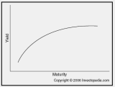

**28. Describe the two variants of asset backed securities. (ABS)**

1. Pay As you go/ Physical Settle
   * Make whole given a soft event.
   * Principal or Interest is paid off.
   * Place Off Balance Sheet
   * Bankruptcy Remote
   * Contract is structured to match the cash flows of the reference obligation
   * Not physically settled!
2. Cash/ Physical Settle

**29. Explain the major features of common CDS indices**

* CDX
* iTraxx.

**30. Describe the major features of single-tranche collateralized debt obligations**

**(CDO).**

* Single tranche collateralize debt obligation is an OTC derivative version of a synthetic collateralized debt obligation.
* Single-tranche CDO or bespoke CDO is an extension of full capital structure synthetic CDO deals, which are a form of collateralized debt obligation. These are bespoke transactions where the bank and the investor work closely to achieve a specific target.
* See Problem -- Senior, Mezzanine, Equity Tranche.

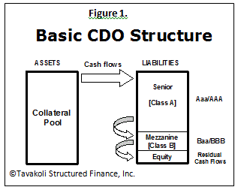

**31. Explain the advantages of single-tranche CDOs compared to traditional CDOs.**

* Single Tranche CDOs saves time and cost
* Customize portion is the only piece which is sold off
* Customize portion is on an investor-defined collateral pool
* There is no waterfall cash flow pattern

The Economics of Structured Finance

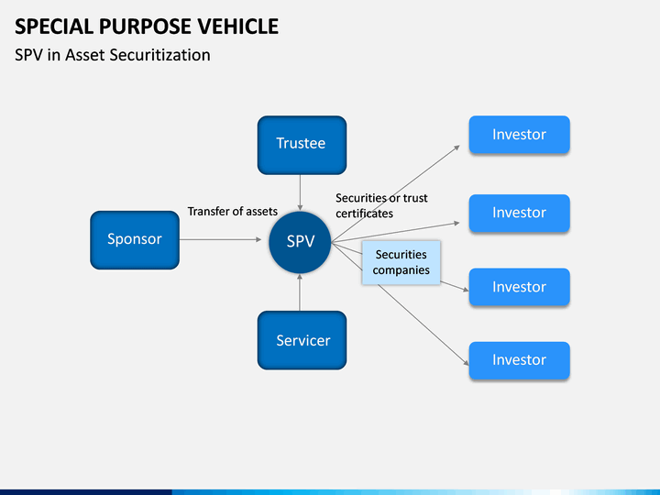

A special purpose vehicle, also called a special purpose entity (SPE), is a subsidiary created by a parent company to isolate financial risk. Its legal status as a separate company makes its obligations secure even if the parent company goes bankrupt.

* CDO2
* Collateralized debt obligation (CDO)
* Investment grade
* Non-conforming mortgages
* Over-collateralization
* Special purpose vehicle (SPV)
* Speculative grade

**1. Describe the process through which financial institutions can create structured products of a given credit rating.**

* First step is a large collection of credit sensitive assets assembled in a portfolio, which is typically referred to as a “special purpose vehicle. SPV. The special purpose vehicle is separate from the originator’s balance sheet to isolate the credit risk of its liabilities – the trances- from the balance sheet of the originator.
* Pooling and Tranching

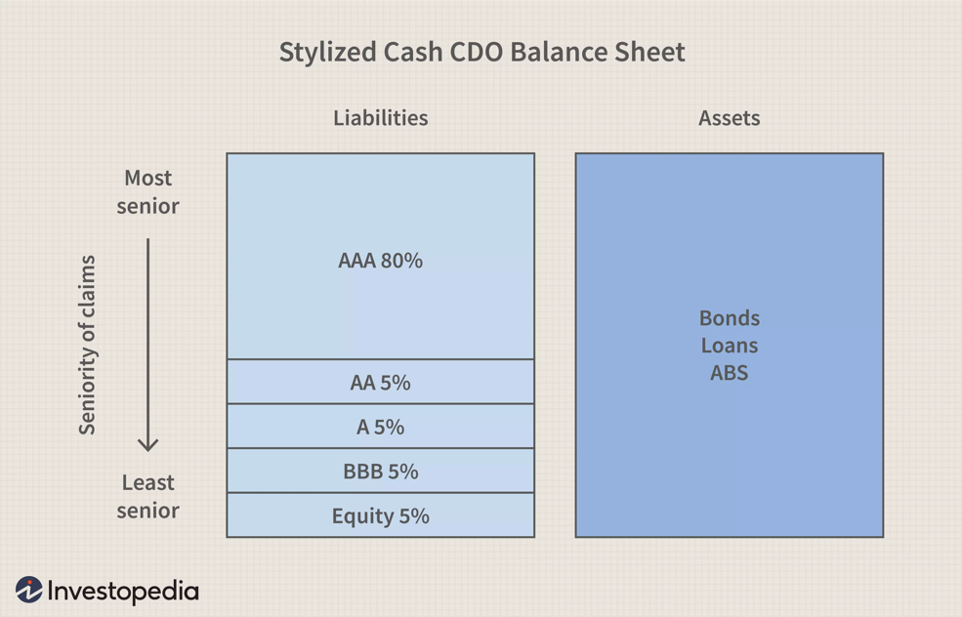

* While CMOs and CDOs have similar wrappers on the outside, they are different on the inside. The CMO is a little easier to understand as the cash flow it provides is from a specific pool of mortgages while the CDO [cash flows](https://www.investopedia.com/terms/c/cashflow.asp) can be backed by automobile loans, [credit card](https://www.investopedia.com/terms/c/creditcard.asp) loans, [commercial loans](https://www.investopedia.com/terms/c/commercial-loan.asp) and even some tranches from a CMO.
* While the CMO market did suffer some impact from [the real estate implosion of 2007](https://www.investopedia.com/articles/economics/09/financial-crisis-review.asp), the CDO market was hit harder.

**2. Describe the importance of default correlation in estimating the credit risk and in transferring default risk between tranches of structured products.**

* Default correlation: is the tendency of assets in the underlying pool to default at approximately the same time.
* If the defaults of the two bonds are imperfectly correlated, the senior tranche will pay either 1 or 0 (just like the individual bonds) except that it will be less likely to default than either of the underlying bonds.
* This basic procedure allows highly risky securities to be repackaged, with some of the resulting tranches sold to investors seeking only safe investments.

**3. Compare and contrast the role of default correlation in the credit risk and credit ratings of single name bonds versus CDO and CDO2 tranches.**

Pg 49. Correlation increase will decrease the chance of default.

* The CDOs created from the tranches of other collateralized debt obligations are typically called CDO squared.
* The development of a bespoke tranche market in recent years has made the pricing and risk management of correlation imperative. As a result each bank has its own model of how this default correlation should be calculated.
* Essentially, the value of the lowest tranches of a CDO, say an equity tranche, increases as the correlation between defaults falls, and decreases as default correlation rises.

**4. Discuss how errors in the assessment of the default correlations, the default probabilities, and the ensuing recovery rates for sub-prime securities can cause underestimation of the likelihood of large losses.**

* The sensitivity of the tranches to errors in the estimate of default probability is determined by their seniority.
* The subprime market experience rapid growth from 1996-2006. Once the real estate bubble popped, the errors made by the rating agencies become evident. Actual default correlation and default probabilities were higher than expected, while recovery rate were lower than expected.

**5. Describe how the process of pooling and tranching creates securities whose payoff profiles resemble those of a digital call option.**

* All or nothing on the digital call option. When the instrument defaults then there is no payment at all.

**6. Assess the systemic (macroeconomic) risk exposures of certain CDO tranches.**

* Subprime destroyed a lot of it

**7. Describe the significance of conflict of interest and perverse incentives in the rise and the fall of the structured finance market.**

* Ratings fees
* Bank fees
* Objective credit risk evaluation

**8. Describe the role of rating agencies, investors, banks and regulators in the rise and the fall of the structured finance market.**

* Rating agencies used flawed ratings models, were overconfident, failed to remain objective, and benefited from CDO market growth.
* Investors outsourced due diligence
* Regulators relied on credit ratings to determine banking capital requirements
* Investment Banks focused on other revenue generation and as buyers, held senior CDO tranches due to regulatory capital and yield advantages.